**Name:zhong zhao**

**ID:2014286190098 Email:1114753650@qq.com**

**Application of GIS in Environmental Management**

**Abstract:** Geographical Information Systems (GIS) are now used more commonly in our daily life. especaially in the field of environment management. Based on the related researches at home and abroad, this paper make a simple introduction for GIS, emphatically discuss the application of environmental management. finally, the development tendency was also discussed.

**Key Words:** Application of gis, protection, management, environment, Spatial-analysis

# 1. Introduction

## 1.1 Introduction of GIS

GIS(Mortaza Saleh.et al,2012) is one of the emerging interdisciplinary that collects computer science, geography, mapping of remote sensing science, environmental science, urban science, space science, information science and management science together. It is based geospatial database using geographic model analysis, timely offers a variety of space, dynamic geographic information for geographic research and geographic decision-making. Computer Support is the main feature, spatial query and spatial analyses is its primary function. Because environmental concerns and geographical factors are closely related, which of them usually being with a strong geographic or geographic distribution, the use of technology can effectively handle large amounts of complex spatial information is based on environmental issues. So in recent years are increasingly being applied to the environment of management, also brought modern data processing tools for environmental management

## 1.2 background

Problems concerning environmental protection are vast. the term "environment" has never been defined in legislation explicitly, nor can one find a definition of environmental protection. in addition, Environmental management is an important  part of the environmental protection .In the economic sciences environmental management means the human behavior that limits damages to the environmental quality by use of measures of legal, economic, administrative, technical and advocacy and education. Through comprehensive planning and effective supervision, to coordinate economic development and environment, and achieving the goals of sustainable development. It has three salient characteristics. First, Comprehensive. Second, Regional. Third, extensiveness. So, it seems that environmental protection refers to any activity to maintain or restore the quality of environmental media through preventing the emission of pollutants or reducing the presence of polluting substances in environ-mental media. It(Mortaza Saleh.et al,2012) may consist of :

(a) changes in characteristics of goods and services

(b) changes in consumption patterns

(c) changes in production techniques

(d) treatment or disposal of residuals in separate environ-mental protection facilities

(e) recycling

(f) prevention of degradation of the landscape and ecosys-tems

A Geographical Information Systems (GIS) is a term introduced in the latter half of the 1960s by Roger Tomlinson(Piotr Dynowski.et al,2013). the reference literature on geographic information systems uses numerous definitions of them formulated at various approaches, e.g. GIS is a toolbox, GIS is an information system, Broadly, GIS encompasses methods ,technical means, spatial data base, organization, financial resources, and people interested in its functioning.

Nowadays, GIS technologies have been widely applied at all scientific fields and practical activities. That can be used to monitor disease outcomes, identify health risks, and design and implement intervention plans.

With environmental management, their use includes a broad spectrum including as a simple formula, and visualization of natural data as maps of animate nature resources, visualization of pollutant concentrations in the environment and their spatial distribution. Moreover, GIS is commonly used for planning and implementing environmental management processes, e.g. water divide areas(Rybaczuk k,2011),hazard monitoring, area usage modeling(Zeilhofer P,2011),or forest protection against hazards. To monitor the environmental status, various data can be retrieved, taking advantage of sensors and remote sensing measuring instruments, thus permitting comprehensive examination of the condition and changes occurring within the natural environment and its valorization, protection, and revitalization.

GIS is applied to analyze the image data of a random nature such as flood risks, disease, and so on.GIS is deployed, too, to monitor environmental condition, Through the spatial-analysis, it can detect hidden information, such as the subtle changes of the plant growth, lake eutrophication. Advanced spatial analyses of can be used to served to carry out the past and present events .thus being of the extreme importance to the application of environmental fields.

# 2 Related work

Ren Jin song (Ren et al,2000) had  used GIS for evaluation of Fujian Meizhou Bay regional environmental quality status, the use of the measured values by interpolation or fitting method is extended to obtain the concentration distribution, understanding the spatial distribution of various pollutants and standard, then the comprehensive evaluation of environmental quality. In addition, GIS technology has been used to build environmental database, the surface water pollution, groundwater pollution path model of path model, and using GIS spatial analysis ability (such as buffer analysis) (Liu et al,2007) analysis for environmental impact assessment in Mexico and the United States border area.

A University of Utah research team (Yanjiang Tao ，2014)have undertaken an environmental impact assessment on Mexico and the United States border area by using GIS technology. the surface water pollution, groundwater pollution path model and the path model, using the spatial analysis ability(such as buffer analysis), the environmental impact caused by the economic development of the region have been evaluated. and Melbourne University's Turk points out that the environment management is a need for a series of law, The complex task constraints and norms of law rules. When GIS technology and other scientific mode applied to the environmental management, we can get a visual display spatial decision support system to the. Cinder by of New York University and Steve in its research, It points out that the modern GIS technology plays a great role in environmental management in the study (Fan et al, 2009).

# 3 Application of GIS in Environmental Management

## 3.1 Air Pollution Monitoring and Management

Air pollution data includes both the number of emissions of various pollutants, including geographic data sources. due to their different location, under the influence of meteorological conditions the same pollutant emissions ,which its degree of pollution and scope will be different . That is characteristic of atmospheric pollution. This feature determines a fact that the total amount of atmospheric pollution monitoring and pollutant emission control are suitable for a GIS technology that combined with the quantitative and spatial analyses. The quantitative analysis of atmospheric pollution monitoring and control of the total discharge of not only to carry out the pollution sources, such as emission calculations size, but also to conduct  spatial analysis, such as the relationship between emissions and environmental concentration calculation . GIS will be represented by the distribution of data, numbers and graphics integration, support for digital thinking and spatial thinking the same time.

## 3.2 Environmental Geographic Information System

Environmental Geographic information system is a spatial information system, with the control management function, input, output, spatial analysis function and multi information under the support of the decision making and simulation function. Specific features include several pieces of information input, information, attribute data statistical analysis, spatial data analysis and decision support, The information input includes attribute data, spatial information, image information and other multimedia .information query combines the attribute information, map information, the information of the image with other multimedia information together.

In order to conduct dynamic monitoring of environmental pollution as well as to respond quickly to major disaster events, the establishment of environmental management of geographic information systems is very essential. currently, cities such as Beijing, Shanghai, Nanjing and other have already established such systems, and environmental management practices has been successfully applied in Gansu province, Remote sensing for land and resources survey of Gansu Province in the near future will also be carried out and establish the focus of urban environmental management information system, after the experience will be gradually popularized to the province. Figure 1 is as follows

System

System setting

Login

Data management

Query

system

Enterprise management subsystem

Enterprise statistic  subsystem

SQL, EXCEL, ACCESS

GIS

Figure 1. Water Environmental Information Management System

## 3.3 GIS and Water Environmental Information Management System

As the water environmental problems closely related to geographical factors, social factors, pollution factor, and usually with a strong geographic or geographic distribution. Meanwhile, environmental information management system has these function of environmental information management, query, statistics, optimization and output, and also be combined with a variety of models and model forecasting, planning, evaluation and decision-making, so that serve for environmental management and decision-making. Water has persistent environmental problems and randomness in time distribution, the use of GIS technology can effectively handle a large number of complex spatial information and time information is based on water environmental issues.

G1S and integrating environmental management information system, the data is converted to map data and information, you can visually display the query, statistics and other performance data to improve the efficiency of environmental management, embedded in the environment more conducive to mining events and phenomena of meaning and laws, environmental management and decision-making. Chart 2 is as follows.

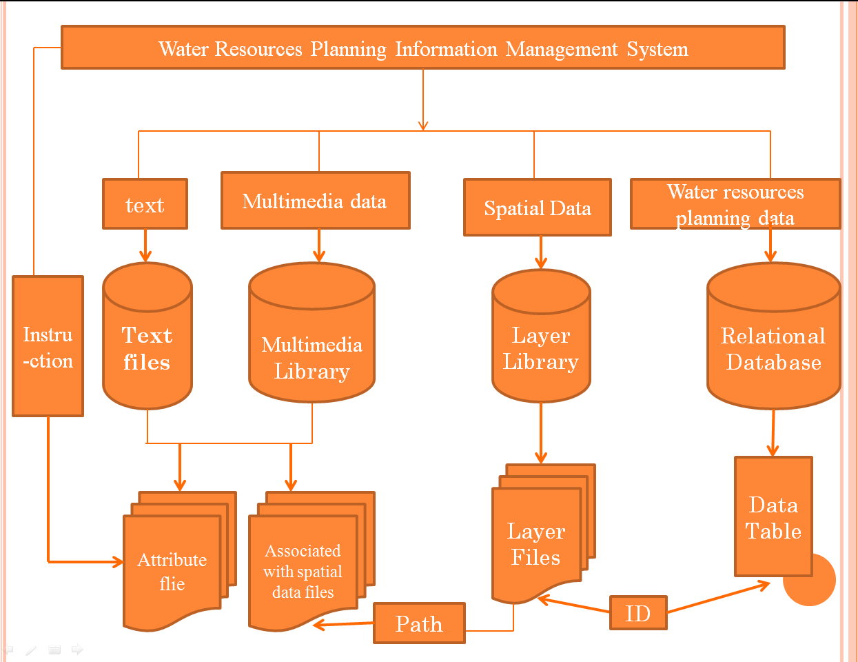

Figure 2 Water Environmental Information Management System

# 4 Prospect

With the continuous development of GIS technology, GIS systems is playing an increasingly important role in environmental protection, it is with a variety of environmental management, analysis system of effectively combination, to provide important technical guidance and advice for environmental workers, improving the environmental monitoring efficiency, reducing the difficulty of the work

Through the application of GIS analysis in the area of the existing environment, we can conclude:

(1) GIS with its highly integrated spatial and geographic characteristics, can provide a wealth of terrain, climate and hydrological data for the majority of workers, the introduction of GIS in the field of environmental protection can fully examine the geographical factors in the environment influence, making more accurate and objective environment management decision-making.

(2) the geographic information system applied to all areas of environmental protection, the use of a large number of GIS can store, update, compute functional data, decision makers can make the environment more timely access to environmental information, and grasp the changes in different areas of contamination, enabling timely adjustments environmental strategy.

(3) GIS system can combine with all kinds of environmental management and analysis system effectively. In the system, Incorporating all kinds of mathematical models, such as pollution, assessment, forecasting and other mathematical models, data that collected by GIS is used to input model for calculation. A variety of effective assessment and decision theory can be immediately obtained solutions for environmental workers, and providing important technical guidance and advice.

# 5 References

**1.Mortaza Saleh，Tahere Yaghoobi，Ahmad Faraahi.2012. A combinational approach of GIS and SOA for performance improvement of organization. International Journal of Web & Semantic Technology (IJWesT). Vol.3:11-22**

**2.Piotr Dynowski , Anna Zrobek-Sokolnk, Hanna Ciecierska, Jan Dziedzic, Ryszard Piotrowicz, Hoidynsk.2013. Application of GIS and GPS Tools in Qualification and Classification of a Lake's Ecological Status. pol.J.environ.Stud. vol.23.No.2: 639-645**

**3. Glossary of Environment Statistics, 1997,Studies in Methods, Series F, No. 67, United Nations, New York.**

**4.Anna Fraszczyk, Corinne Mulley.2014. GIS as a tool for selection of sample areas in a travel behaviour survey. Journal of Transport Geography.2014(34): 233-242**

**5.Ren JinSong, Ren Fuhu.1990. Evaluation of the Regional Environmental Status under the support of geographic information systems. Environmental Science.1990,11(6):62～67**

**6.Liu Yong, Jing Wenyong .1997.GIS technology and its application in environmental science. Environmental Science 1997,18 (2): 62-65**

**7.Fan Yang, Sun ShuiYu, 2009. GIS applications in environmental protection . Energy Resources and Environmental Mitigation .2009(10): 128 ~ 129.**

**8.Yanjiang Tao .2014. geographic information system (GIS) applications . Energy and Environmental Protection in mining .2014 (09): 132-133**

**9.Su Lin Xiang, Zhou Wenbin.2009. Design and development of Poyang Lake water environment geographic information system. Journal of EastChina Jiaotong University.2009(02):13-16**

**10. He Yan. Xu Jianming. Shi JiaChun. 2003 . GIS application and development in environmental protection. Environmental Pollution and Control.2003(06):359-361**

**11. Hudak P F.2000. Regional trends in nitrate content of Texas ground-**

**water. Journal of Hydrology. 2000,228 (1/2):37～47**

**12. Wei Zhirong. 2006. The main problems of environmental management in our country and the countermeasures . Northern Economy and Trade. 2006 (6) : 110-111**

**13.Wang Haibo, Du Qiugen, Xing Guoyi, Li Xiaoyuan. 2005. Application of GIS in environmental management. Yunnan environmental science. 2005(24): 60-63**

**14. Zhang Jun.2004.GIS technology and its application in environmental management in the . agricultural network information, 2004(5): 11-14.**

**15. Zhang Yu.  2010. Spatial decision support system and Application Research of GIS. in urban environmental management in China based on science and technology. 2010(14): 137-138.**

**16.** **Małgorzata Gajos,Edyta Sierka.2012.GIS Technology in Environmental Protection: Research Directions Based on Literature Review.** **Pol. J. Environ. Stud.** **2 (2012):241-248**